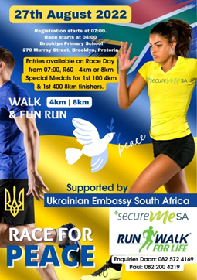  The main partners:  Secure Me SA  Ichikowitz Family Foundation  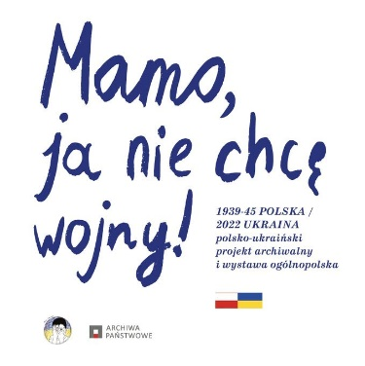  The main partner:  Embassy of the Republic of Poland in Pretoria | Run/Walk for Peace charity marathon  On August 24, Ukraine celebrates Independence Day. Unfortunately, this year this date coincides with 6 months of Russia's brutal invasion of the territory of the sovereign state of Ukraine. In this regard, the Embassy of Ukraine in Pretoria does not hold an official reception. Instead, we invited all South Africans, members of the diplomatic corps, and Ukrainians in SA to join the charity marathon Run/Walk for Peace.  We hope to be able to hold this event annually.  This year, all entry fees will be transferred to the platform United24 https://u24.gov.ua/ launched by the President of Ukraine Volodymyr Zelenskyy as the main venue for collecting charitable donations in support of Ukraine.  The registration starts at 7h00  The race starts at 8h00  The point of registration and the start is Brooklyn Primary School (279 Murray Street, Brooklyn, Pretoria)  Mum, I don't Want War exhibition  It's the project of the State Archives of Poland in cooperation with the Ukrainian foundation "Mother, I see war". In South Africa, the exhibition is presented due to the Embassy of the Republic of Poland in Pretoria.  The exhibition represents the copies of the drawings of Polish children, made immediately after the end of the Second World War, as well as ones of Ukrainian children who today are forced to hide in basements, hear bomb explosions, and see the death of their relatives as a result of the massacre unleashed by Russia in the 21st century in the center of Europe.  The exhibition will be opened at the same time near the Embassy's main entrance (398 Marais Street, Brooklyn, Pretoria).

